Intro to Programming (Python)

Assignment 07:

Overview
In this activity, you will learn about exception handling and Python’s pickling module, and how you use them.

So far, I have provided links for you, but now it is your turn to do the research! I am hoping this will be pretty easy for you, since you have visited a lot of websites while performing the other modules.

One last twist; instead of using Word documents for your write-ups you will create a free Google Blog (Instruction are lower down in this document). Of course, your blog will be reviewed by your peers, so make your document and code look professional as you can while getting used to the Blogger interface. Don’t stress if the Blog does not look as nice as your Word document would have, it seldom does!

This assignment will include the following:
- Watch the Module Videos.
- Research Exception handling in Python
- Research Pickling in Python
- Apply your knowledge.
- Document your knowledge in a Blog.
- Submit your work.
- Perform a Peer Review.

Step 1: Watch the Module Videos:
Module 07 Playlist:
https://www.youtube.com/playlist?list=PLfycUyp06LG_Rg7NYLURKCS-Y1wtAkILW

Step 2: Research Exception handling in Python:
Search the web for examples of how to use Python’s Exception handing features.

Step 3: Research Pickling in Python:
Search the web for examples of how to use Python’s Pickling features.

Step 4: Apply your knowledge
Now that you have reviewed the websites and videos, try to do the following tasks.

- Create a simple example of how you would use Python Exception Handling. Make sure to comment your code.

- Create a simple example of how you would use Python Pickling. Make sure to comment your code.

Step 5: Document your knowledge
Create a simple Blog on Google’s Blogger to outline the steps you took in performing this assignment. Here is an example of what one might look like:
http://pythonsummer2015rroot.blogspot.com/

I have created a video that will instruct you on the process. You can find the Video:
https://youtu.be/L8kePEXR7zk

Tips:

- The video will show you how you can use simple Copy and Paste techniques if that helps. (I often start with a document in Microsoft Word and then copy and paste it into the Blog)

- You do not need to use your personal Google account for this. You can make a new account just for this if you wish to remain anonymous

- This is a great way to show you employer or future employers your new coding skills. You can later link your blog in emails, Linked-in, Facebook, or even on resumes.

- Students often hate the Blog at first, but later come to see the advantages. So, hang in there! You can always delete it later.

- Just get it looking good enough for the assignment. You can always update it later to look better when you have more experience.

NOTE: If you cannot create a Blog, you can turn in a Word document as usual.

Step 6: Submit your work
Copy and paste the link to your Blog in the class assignment Submit page.

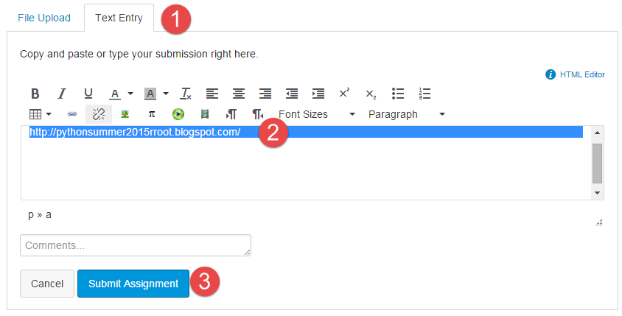

Step 7: Post your document
In this module, you need to post a link to your Blog in the discussion forum so that others may review it. Just add your link to the “Assignment 07 Links for Review.”

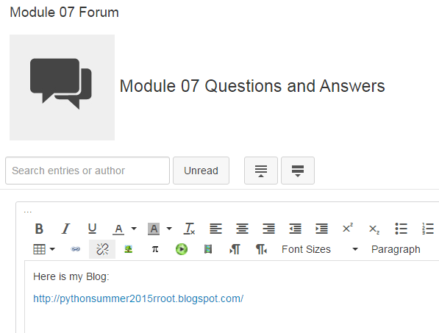

Step 8: Perform a Peer Review
You will be randonly assigned a review parter by Canvas after the assignment due date. Please read the assignment turned in by this student and comment on the discussion forum.

- One thing that you liked about their blog
- One thing that could make the blog better

You are done!

